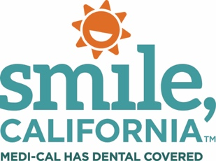

SmileCalifornia.org

Dear Medi-Cal Member,

Keeping your teeth healthy is one of the best things you can do for your overall health. Daily brushing and flossing are important healthy habits, and so is going to the dentist regularly.

As Medi-Cal members, your benefits and your child’s benefits include dental coverage!
Medi-Cal provides free or low-cost dental services to help keep you and your smile healthy. Remember:
• First tooth or first birthday. Your baby should visit the dentist as soon as their first tooth comes in or by their first birthday, whichever comes first.

• Seal today to prevent decay. Talk to your child’s dentist about molar sealants. These protective coatings help prevent cavities.

• Adult dental benefits have been fully restored. As of January 1, 2018, the Department of Health Care Services (DHCS) restored adult dental benefits for members ages 21 and older with full-scope dental coverage.

Learn more about your dental benefit and find a Medi-Cal dentist near you at SmileCalifornia.org or call the Denti-Cal Customer Service Line at 1-866-290-6310. The call is free! Medi-Cal Dental representatives are available to answer your questions from 8:00 a.m. to 5:00 p.m., Monday through Friday.

Representatives can help you with:

• Finding a dentist.
• Scheduling a dental appointment.
• Finding out more about your dental benefits.
• Answering questions about the Medi-Cal Dental Program.
• Getting information on fraud and abuse.
• Getting information on resolving problems with dental care. Please mention this letter when you call.

Sincerely,

Medi-Cal Dental Program
Department of Health Care Services

PO Box 15539
Sacramento, CA 95852-0609 www.denti-cal.ca.gov

