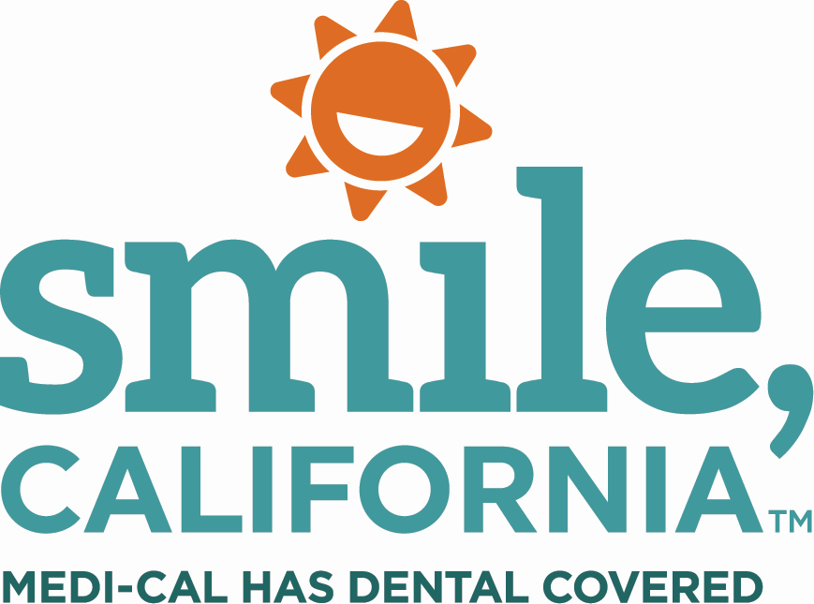

Healthy Foods, Big Smiles Suggested Captions:
In English:
Heathy foods = big smiles. Good oral health takes more than just brushing and flossing. Eating a balanced diet and visiting the dentist for regular checkups are also important to keep your smile healthy.
Visit SmileCalifornia.org to find a Medi-Cal dentist near you.
Use the hashtags: #SmileCalifornia #FindADentist
In Spanish:
Alimentos saludables = grandes sonrisas. Para tener una boca sana, usted debe hacer más que solo cepillarse y usar hilo dental; tambien debe de comer una dieta balanceada y visitar al dentista regularmente para mantener su sonrisa saludable.
Visite SonrieCalifornia.org para encontrar un dentista de Medi-Cal cerca de usted.
Utilize los hashtags: #SonrieCalifornia #SmileCalifornia

