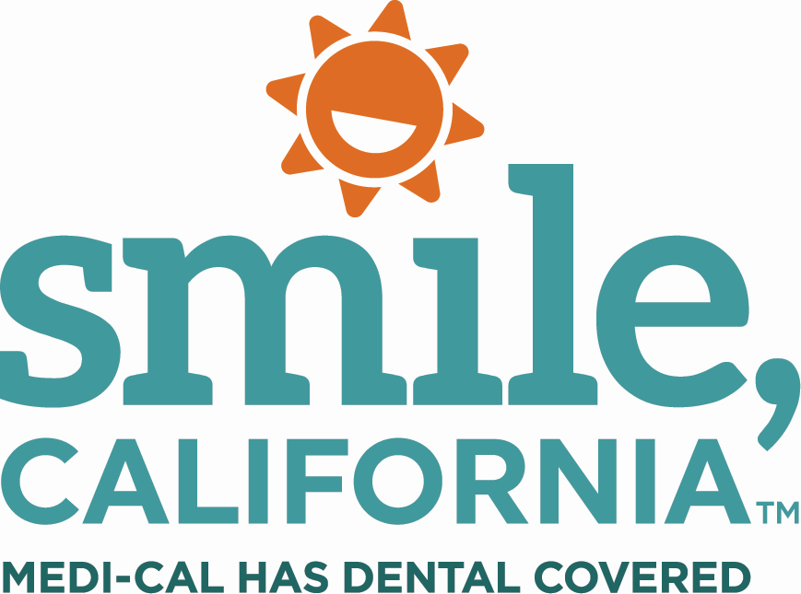

Molar Sealant Questions & Answers English Suggested Social Media Caption:

Did you know that molar sealants can help reduce the risk of your child getting cavities by 80%?

Children start to lose their baby teeth as early as five years old. This is when their permanent teeth begin to grow in. You can protect your child’s back teeth from cavities with sealants. Molar sealants are protective coatings that are quick and painless.

Sealants are a part of your child’s Medi-Cal dental benefit and can protect your child’s back teeth for several years!

For more information on covered services or to find a dentist near you, visit SmileCalifornia.org/MSM.

Use the hashtags: #SmileCalifornia #MolarSealantMarch

