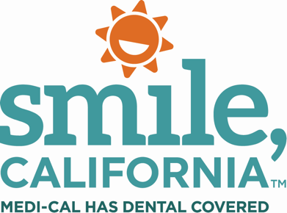

Back-Tooth-School Twitter Message Options

Option A:
Good oral health habits, like regular brushing, flossing and dental check-ups can help children succeed in the classroom. Medi-Cal covers two dental check-ups and cleanings a year for members under the age of 21. #BackToothSchoolCA #SmileCalifornia SmileCalifornia.org

Option B:
At-home dental care is important but is not a substitute for regular dental visits. Regular dental visits also allow parents and children to develop trust with the dental staff and gives them a better chance to prevent dental problems. #SmileCalifornia SmileCalifornia.org

Option C:
Fluoride varnish is a gel that is put on teeth and only takes a few minutes to apply. Fluoride varnishes are covered by Medi-Cal every 12 months for adults and more often for children, depending on their age. #BackToothSchoolCA #SmileCalifornia SmileCalifornia.org

Option D:
Sealants are a great way to protect your child’s teeth from cavities. These quick and painless coatings are applied to the back teeth and help reduce the risk of cavities by 80%. They are covered by Medi-Cal for members under the age of 21. #SmileCalifornia SmileCalifornia.org

Option E:
It is important to continue regular dental check-ups throughout the teen years to ensure good oral health well into adulthood. Medi-Cal covers two dental check-ups and cleanings a year for members under the age of 21. #BackToothSchoolCA #SmileCalifornia SmileCalifornia.org

