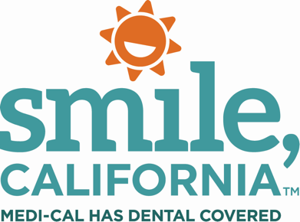

Back-Tooth-School E-mail Signature Taglines

Copy and paste one of the tagline options below to your e-mail signature, or to the bottom of outgoing e-mails, to help promote the 2022 Back-Tooth-School promotion with your contacts and community.

E-mail Tagline #1:

A good school year begins with a dental check-up.
SmileCalifornia.org/School-Readiness

E-mail Tagline #2:

Dentists and hygienists have the power to protect your smile.
Medi-Cal covers check-ups for children.
SmileCalifornia.org/School-Readiness

E-mail Tagline #3:

Healthy smiles help children perform better in school.
Sealants reduce cavities by 80% and are covered by Medi-Cal Dental for members.
SmileCalifornia.org/School-Readiness

E-mail Tagline #4:

Medi-Cal covers dental check-ups for children and teens to be ready for school.
SmileCalifornia.org/School-Readiness

E-mail Tagline #5:
Children are required to have a dental assessment by May 31 of their first year in school.
SmileCalifornia.org/School-Readiness

